DATE: **February 15th, 2021**

TO: **Dr. Deirdre Hunter**

FROM: **Sindhuja Darisipudi, Nora Han, Joseph Urso, Michael Tang, Jason Ye[1]**

**Team Moonrats (**[**5moonrats@gmail.com**](mailto:5moonrats@gmail.com)**)**

SUBJECT: **Water Assessment Incubator Need-to-Know List & Research for a Design**

**Context Review**

**Research for Design Context Review**

Our design challenge is to build a portable incubator that enables E. coli to be grown on Petrifilms. Observing this growth of E. coli allows for water sanitation to be evaluated in remote areas. In order to better understand this problem, it was necessary to research into existing solutions, what governs the problem, relevant background, and the business perspective behind creating our product.

Exploration of existing solutions was a particularly important research area, as our incubator is intended as the second iteration of an existing solution designed by our client, Public Invention. Hence, we placed a large focus on understanding the nuances of the previous design, which allowed us to identify aspects to keep and change. Our second area of focus was on similar solutions of low-cost incubators for life—specifically, baby and egg incubators. We chose this area because such incubators are commonly used in low-resource areas, which is precisely the setting our incubator will be operating in. These were particularly useful areas of research, as the temperature and reliability expectations of these incubators are often tighter than what is needed for our purposes, and hence serve as a good starting point.

Since our design challenge is grounded in the life sciences, we also needed to understand how E. Coli grows in an incubator. Hence, we conducted research into what governs our design problem by honing into the biological constraints involved in growing E. Coli.

For relevant background, we aimed to gain a deeper technical understanding of each core component that would comprise our final design: insulation, heating, cooling, data logging, and battery properties. While this choice of research topics is quite broad, we deemed it necessary to have a good grasp of each individual component of our design before trying to piece them together.

Finally, we deemed business perspective as the least important area of research. This was because, per our client, a group of researchers will purchase a single unit of our design, and use it for water sanitation testing for at least one year.

**Need-to-Know List**

Before beginning the actual research process, we first brainstormed an extensive list of information we would potentially need to solve our design problem. These topics were categorized into understanding existing solutions, what governs our problem, relevant background, and the business perspective behind our design problem.

**Exploration of existing solutions**

* Existing solutions
  + First prototype (the Armadillo model)
  + DIY Incubators
    - DIY heating pads, heating sources
* Historical solutions
  + Look into different methods for testing water bacteria
  + Look into how the field researchers used to keep the petrifilm warm
  + Electricity-free incubation
  + Understand what happens to E.Coli on Petrifilms if not incubated
* Similar problems
  + How to insulate in very hot climates
  + How to insulate in colder climates
  + How to regulate humidity
* Similar solutions
  + Low cost incubators for babies
  + Wet lab insulators
  + Egg incubators
  + Thermos & yeti bottles (insulation)
  + Portable fridge
  + Portable toaster
  + Heating blanket
* Analogous solutions
  + Common heating/cooling methods in low-resource areas
  + Swimming pool temperature control system
  + Vibration-absorptive material
  + Backpack designs
  + Thermal insulation bag (silver light reflective material)

**What governs the problem**

* Limitations
  + Average backpack size
  + Maximum weight an average backpack can hold
  + Maximum and minimum temperatures under which E. Coli can survive
  + Maximum and minimum humidity conditions under which E. Coli can survive
* Standards
  + Standards for water quality
* Regulations
  + Look into potential biological regulations
  + Health regulations for potential insulator materials

**Relevant background**

* Domain
  + E. Coli
    - How it responds to different environments
    - Maximum and minimum conditions for E. Coli life
  + Electrical Terminology: look at [definitions](https://testguy.net/content/200-Basic-Electrical-Terms-and-Definitions)
  + Petrifilm [background](https://www.3m.com/3M/en_US/company-us/all-3m-products/~/ECOLICT-3M-Petrifilm-E-coli-Coliform-Count-Plates/?N=5002385+3293785155&rt=rud)/how it works
  + Temperature control & monitoring mechanisms
    - **Look at various heating mechanisms!!**
  + Temperature sensitive alarm mechanisms
  + Digital displays & how they work
  + Types of batteries, how long they last, how they charge, etc.
  + Microcontrollers
  + Data logging vs data storage
  + Data logging in various applications; how it can be implemented via Arduino/Raspi etc.
* History
  + Look at “original” incubators
    - How are chicken eggs/other animals incubated historically
    - How were premature babies incubated in the past
* Problem breakdown
  + Look into different ways to heat/heating elements
  + Look at different types of insulation to keep the heat once it has heated up
    - Maybe look into ways to cool it down?
  + Different types of power sources
  + Look into temperature measurement mechanisms
  + Look at sealing methods
* Principles
  + Heat transfer methods
  + Insulation
  + Humidity control
  + Data tracking mechanisms
* User persona
  + Trained professional working in remote setting

**Business perspective**

* Understanding how NGOs operate, and their business models for purchasing
* Cost of final product
  + Ideally around same price as old incubator
    - Look into average cost of an incubator
      * Pet Incubator: $400 - $1500
      * Lab (Tubes): $100 - $500
      * Chicken: $30 - $600
    - Consider price of old model
      * Approximately $171
* Manufacturing considerations
  + Construction should be simple enough for one person to follow in a workshop
    - Specified instructions on construction?
* Patents
  + Ensure there’s no patents in anything that we consider constructing
    - Insulation patents

**Research Worksheets on Exploration of Existing Solutions**

**Name of Source** (eg. The New York Times, or, Handbook of Materials):

International Journal of Simulation

**Location of Source** (include enough information that someone else could find it):

<https://ijssst.info/Vol-17/No-41/paper35.pdf>

**Problem Context Area** (circle one that fits the best):

| Exploration of existing solutions | Governs the problem | Background | Business perspective |
| --- | --- | --- | --- |

**Summary of key points from source** (this summary should be thorough enough that you do not need to return to the source when writing your DCR or continuing the project):

This paper details how to create a temperature regulating incubator for eggs using Arduino Unos

- Eggs maintained at 37 C

- Use 2 Arduino Unos

- One processes all sensors, and determines what system is doing (ie. turn on fan, turn on alarm, etc.) based on results from sensors

- The first Arduino tells what to do to the 2nd arduino, which is the one that actually communicates that to system

- Relay is necessary to get enough voltage for fan

- Casing is hardwood

- 2 layers inside:

- First (lower) is what eggs are placed on

- Second is for controller system (temp, fan, bulbs, humidity)

- Uses mirror at door so you can look inside incubator

- General operation

- If temp gets too low, then light goes on; if light gets too high, then fan turns on. When it settles at option, both will be turned off

- Uses a motion sensor to detect if eggs hatch

- Also includes manual mode to turn on and off fans/lights

**Name of Source** (eg. The New York Times, or, Handbook of Materials):

3M Attest biological incubator instructions

**Location of Source** (include enough information that someone else could find it):

<https://multimedia.3m.com/mws/media/1028058O/3m-attest-steam-incubator-56c-instructions-for-use.pdf>

**Problem Context Area** (circle one that fits the best):

| Exploration of existing solutions | Governs the problem | Background | Business perspective |
| --- | --- | --- | --- |

**Summary of key points from source** (this summary should be thorough enough that you do not need to return to the source when writing your DCR or continuing the project):

This paper details a steam incubator created by 3M to allow active monitoring of the steam sterilization process

- Incubator must be plugged in 30 minutes before use to warm up

- Needs to be operated with safety glasses/gloves

- internal temperature is kept extremely rigid at 56 degrees C +/- 2 degrees C

- Heading is done through a metal heating block wall

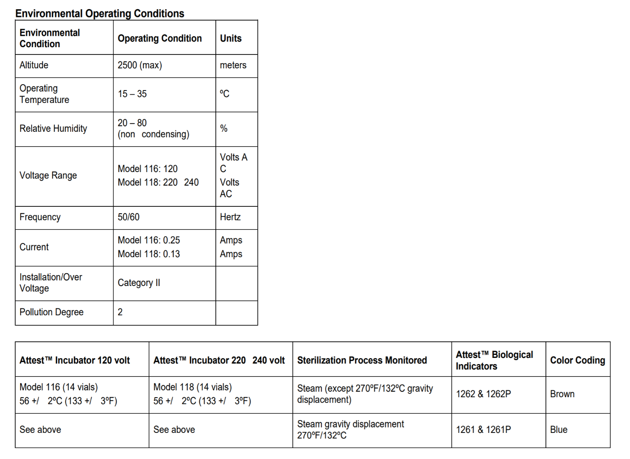

**Name of Source** (eg. The New York Times, or, Handbook of Materials):

BINDER official site

**Location of Source** (include enough information that someone else could find it):

<https://www.binder-world.com/us/products/standard-incubators/series-b-classicline/b-28#1>

**Problem Context Area** (circle one that fits the best):

| Exploration of existing solutions | Governs the problem | Background | Business perspective |
| --- | --- | --- | --- |

**Summary of key points from source** (this summary should be thorough enough that you do not need to return to the source when writing your DCR or continuing the project):

This paper detail a commercial incubator by Binder corporation

- Uses inner glass door made of tempered glass for incubator to maintain temperature

- Uses a hydro-mechanical thermostat

- Is stackable

- Uses chrome-plated racks

- can go from 30-70 degrees C

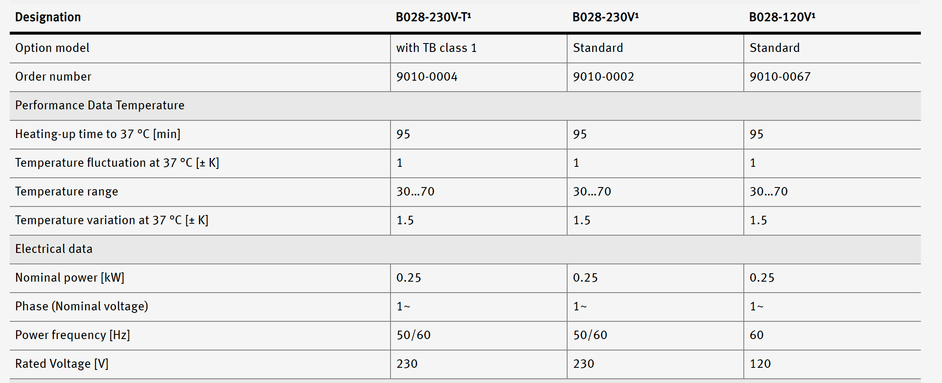

**Name of Source** (eg. The New York Times, or, Handbook of Materials):

JoVE Journal

**Location of Source** (include enough information that someone else could find it):

<https://www.jove.com/t/58443/construction-low-cost-mobile-incubator-for-field-laboratory?status=a60449k>

**Problem Context Area** (circle one that fits the best):

| Exploration of existing solutions | Governs the problem | Background | Business perspective |
| --- | --- | --- | --- |

**Summary of key points from source** (this summary should be thorough enough that you do not need to return to the source when writing your DCR or continuing the project):

This paper details the construction of a low cost mobile incubator for field use.

- E. Coli is incubated at 35-37 C

- Used 2 axial fans (60 x 60 x 25 mm)

- Used PID temperature controller (quite large, like a rod)

- Used electrical core control unit as well as heating foils, self-adhesive to get consistent heating

- Utilized a support rack with large holes to avoid heat accumulation in rack

- Recommends either a shell of polystyrene foam or a hard cooler box

- total cost of their incubator: $300

- Fans and heating foils are all placed on single metal sheet

- Temperature was proven to be stable over 24 hours

- They did tests to see temperature change when door of incubator was opened for one minute

- Heat loss was greater for cold environment outside

- Also tested with a standard survival blanket wrapped around a cardboard box

- Results not great, never reached temperature

**Name of Source** (eg. The New York Times, or, Handbook of Materials):

Journal of Humanitarian Engineering

**Location of Source** (include enough information that someone else could find it):

<http://jhe.ewb.org.au/index.php/jhe/article/view/127>

<https://doi.org/10.36479/jhe.v6i2.127>

click on the “summary paper” tab and “final manuscript” tab under the picture to download the papers.

**Problem Context Area** (circle one that fits the best):

| Exploration of existing solutions |  |  |  |
| --- | --- | --- | --- |

**Summary of key points from source** (this summary should be thorough enough that you do not need to return to the source when writing your DCR or continuing the project):

Humanitarian engineers need an inexpensive, fast, visually compelling way to assess bacterial water quality in remote locations. One way to do this is with 3M Petrifilm E. coli/Coliform (EC) Count Plates to detect E. coli in water samples. These require incubation at close to body temperature. They provide a free, open-source design of a battery-powered incubator capable of maintaining 35°C ± 1°C for up to 65 hours in ambient temperature of 25°C. Their incubator, called the Armadillo, can be replicated by an ordinarily skilled person in five hours for under USD $200.00 in materials cost. This paper summarises the reference documentation for construction, sample handling, inoculation, and incubation using Petrifilms and the Armadillo. Colony-forming unit (CFU) counts generated by the Armadillo are compared side-by-side with a laboratory-grade incubator. Incubation performance at ambient temperatures of 25°C and 4°C shows that a single battery charge reliably powers a full incubation period of 48 hours under normal ambient temperatures.

The Armadillo’s durable exterior shell and firm interior insulation provides maximum protection against impact from drops and accidents. Its inner chamber holds samples in place securely. Its leak-resistant and rugged design also provides protection against all weather conditions. Importantly, it also protects the Petrifilms from sunlight, a potential threat of sanitising the sample or film.

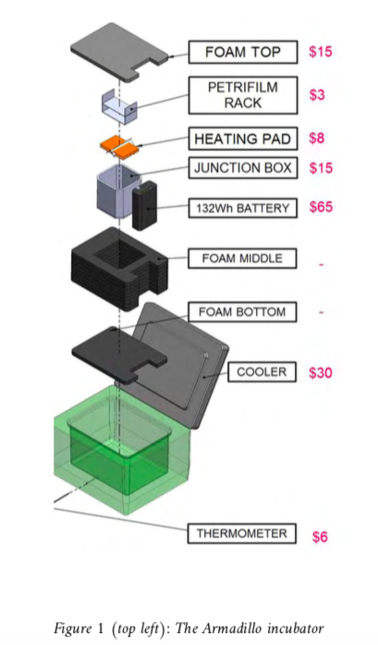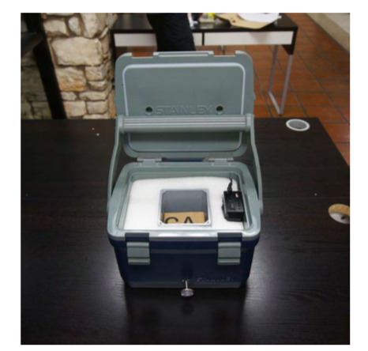

The durable construction and flat top of the Armadillo doubles as a seat, and adjustable tie downs on the incubator lid functions to carry additional tools and supplies. Additionally, the incubator battery may deliver power to any USB-chargeable device, including many personal cell phones and cameras.

**Name of Source** (eg. The New York Times, or, Handbook of Materials):

Instructable Circuits

**Location of Source** (include enough information that someone else could find it):

<https://www.instructables.com/Portable-Petrifilm-Incubator-for-Inexpensive-In-Fi/>

**Problem Context Area** (circle one that fits the best):

| Exploration of existing solutions |  |  |  |
| --- | --- | --- | --- |

**Summary of key points from source** (this summary should be thorough enough that you do not need to return to the source when writing your DCR or continuing the project):

This article details how to build a DIY portable cheap incubator for field use.

1. Thermometer is provided for temperature reading, but NO data tracking mechanism or temperature alarming/battery alarming system is designed.
2. Batteries need warm outside environment to keep functioning
3. No timer is designed for counting 48 hours incubation
4. Relative raw thermal insulation property(foam)

**Materials needed:**

Insulated Container (recommended: Stanley Adventure Series 7 Quart Cooler)

2 Resistive Heating Pads

Count Up Timer (optional)

12V Thermostat

12V Lithium Ion Battery 10Ah [7 X 18650 cells]

Closed Cell Foam Insulation

Inner Chamber (we used a 4"x4"x4" junction box)

3 Circuit Terminal Block Speaker Wire

Thermometer

Add-a-Fuse Crimp kit

Printed PDF Templates (Note: Each of the six templates should be printed on a single sheet of paper at 100% size.)

The total cost is estimated at $150 to $200.

**Tools:**

Wire strippers

Drill

5/32" and 3/8" drill bit

Computer and Printer (to print 1:1 patterns)

Box cutter

Hot glue gun

Screwdriver

Multimeter

**Name of Source** (eg. The New York Times, or, Handbook of Materials):

International Journal of Innovative Research in Science, Engineering and Technology (IJIRSET)

**Location of Source** (include enough information that someone else could find it):

<http://tamminainfotech.com/training/downloads/smartcard/MICROCONTROLLERBASEDBABYINCUBATORUSINGSENSORS.pdf>

**Problem Context Area** (circle one that fits the best):

| Exploration of existing solutions | Governs the problem | Background | Business perspective |
| --- | --- | --- | --- |

**Summary of key points from source** (this summary should be thorough enough that you do not need to return to the source when writing your DCR or continuing the project):

This paper details how to make a microcontroller based baby incubator.

- A good baby incubator need to tightly regulate both temperature and humidity

- Uses single-chip microcontroller

- Has temperature sensor, pressure sensor (for humidity from incubator), respiration sensor (for data from baby), LCD Display

- Temperature sensor types include LIG thermometers, bimetallic thermometers, resistance thermometers, thermocouples, radiometers

- They used LM35 (precision IC temperature sensor) - low self-heating, does not cause more than 0.1 C temperature rise, operating temperature -55 to 150 C

- Makes so fan will get switched on if temp is too high, and bulb (heat source) is switched on if too low

- Pressure sensor — they use MPXx5050 series piezoresistive transducer

- The have a SIM GSM MODEM as well

- can accept any GSM network operator SIM card

- Can be used to send/receive SMS

- Relay board

- 4 channel relay board @ 12V

- good for switching 240V appliances

- Microcontroller - they use PIC 16F877A (good because very cheap)

- 12V Cooling fans

- The relay circuit (above) switches the 5V of the microcontroller to 12V, which is required to run the fan

- Specific fan not specified

**Name of Source** (eg. The New York Times, or, Handbook of Materials):

Wiley Online Library

**Location of Source** (include enough information that someone else could find it):

<https://onlinelibrary.wiley.com/doi/full/10.1111/j.1748-5827.2009.00758.x>

**Problem Context Area** (circle one that fits the best):

| Exploration of existing solutions | Governs the problem | Background | Business perspective |
| --- | --- | --- | --- |

**Summary of key points from source** (this summary should be thorough enough that you do not need to return to the source when writing your DCR or continuing the project):

This paper details the use of aluminum steamed blankets and gel pads for keeping dogs warm during surgery.

- Use case - for keeping dogs warm for surgery

- Used aluminum steamed blanket

- Commonly used in first aid in humans

- Aluminum steamed side of sheet reflects heat (and so decreases heat los by radiation and convection)

- Also tested gel pads (which are more standard)

- You first keep temperature warm in a cupboard or controlled heating area at a particular temperature threshold

- Then, they test temperature of gel pads using mercury thermometer

- Results:

- The aluminum reflective sheet was effective, and deemed a success

- They were unable to monitor temperature of gel pads very well

- Despite that, there was very little effect between gel pads and body temperature of dogs

**Research Worksheets on Background, Business Perspective, and Governs the Problem**

**Name of Source** (eg. The New York Times, or, Handbook of Materials):

International Journal of Engineering and Advanced Technology [“Design and Implementation of](https://citeseerx.ist.psu.edu/viewdoc/download?doi=10.1.1.477.4755&rep=rep1&type=pdf)

[Microcontroller Based Temperature Data Logging System”](https://citeseerx.ist.psu.edu/viewdoc/download?doi=10.1.1.477.4755&rep=rep1&type=pdf)

**Location of Source** (include enough information that someone else could find it):

The Pennsylvania State University Website

**Problem Context Area** (circle one that fits the best):

| Exploration of existing solutions | Governs the problem | **Background** | Business perspective |
| --- | --- | --- | --- |

**Summary of key points from source** (this summary should be thorough enough that you do not need to return to the source when writing your DCR or continuing the project):

TI’s LM 35 is a precision integrated-circuit temperature sensor that gives an specific output

voltage depending on the sensed temperature. The output voltage can then be passed through an

amplifier to amplify the output voltage, and then linked to a microprocessor chip like the

LPC 2148, which will then convert the signal into a format that can be displayed. As long as

lost energy to resistance is kept in mind, this can then be used to output the temperature

on a digital display. It operates between 4 and 30V, and is guaranteed accuracy within half a centigrade. The LM 35 is classified as an analog output chip.

**Name of Source** (eg. The New York Times, or, Handbook of Materials):

The Canadian Architect  [“Radiant Solutions”](http://ezproxy.rice.edu/login?url=https://www-proquest-com.ezproxy.rice.edu/trade-journals/radiant-solutions/docview/213332732/se-2?accountid=7064)

**Location of Source** (include enough information that someone else could find it):

ProQuest via Rice Fondren Library

**Problem Context Area** (circle one that fits the best):

| Exploration of existing solutions | Governs the problem | **Background** | Business perspective |
| --- | --- | --- | --- |

**Summary of key points from source** (this summary should be thorough enough that you do not need to return to the source when writing your DCR or continuing the project):

Radiant heating is a low-cost and effective way to manage energy in buildings. It is also an

energy efficient method of heating. This efficiency comes with using a in-slab tubing method

that allows for energy storing to occur throughout the structures. Once temperatures

stabilize, the system allows efficiency by controlling which specific areas require additional heat.

This method also prevents condensation in most climates.

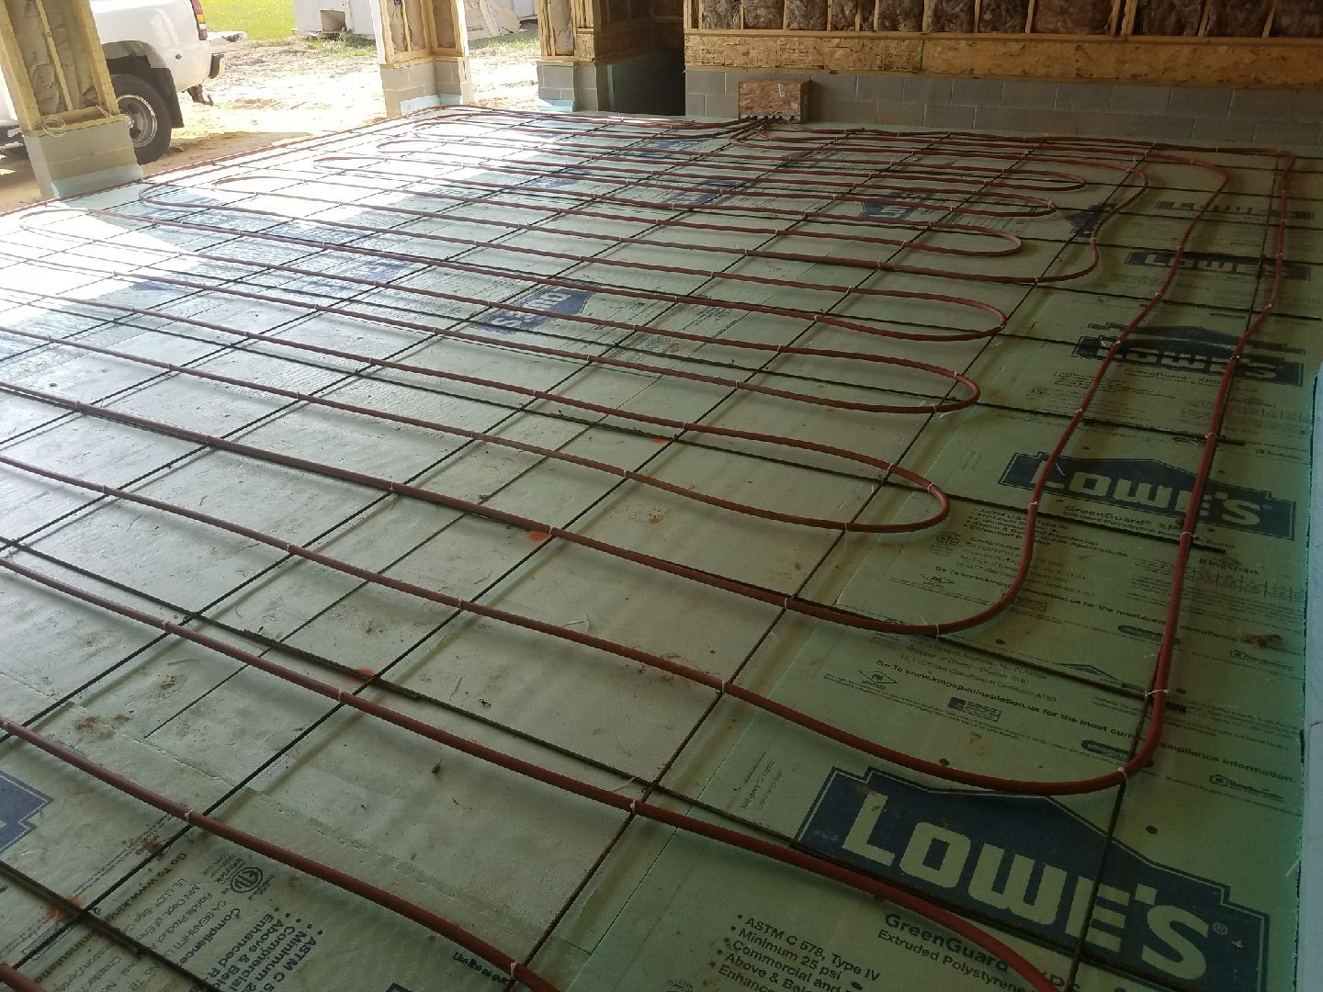

**Reference: In-slab tubing method**

**Name of Source** (eg. The New York Times, or, Handbook of Materials):

ScienceDirect “[Performance characteristics and practical applications of common building](https://www.sciencedirect.com/science/article/pii/S0360132304001878?casa_token=LyQhGoaItR0AAAAA:lqGXKguejtZRFGHsxcRPqgYgHzvjVaRy6zw9GgW3NFguVGyTMgvedAePdiQ7ymxKj28BBXP9E94)

[thermal insulation materials](https://www.sciencedirect.com/science/article/pii/S0360132304001878?casa_token=LyQhGoaItR0AAAAA:lqGXKguejtZRFGHsxcRPqgYgHzvjVaRy6zw9GgW3NFguVGyTMgvedAePdiQ7ymxKj28BBXP9E94)”

**Location of Source** (include enough information that someone else could find it):

ScienceDirect website

**Problem Context Area** (circle one that fits the best):

| Exploration of existing solutions | Governs the problem | **Background** | Business perspective |
| --- | --- | --- | --- |

**Summary of key points from source** (this summary should be thorough enough that you do not need to return to the source when writing your DCR or continuing the project):

The main forms of insulation are: loose-fill foam, blanket batt or roll foam, rigid foam, foamed

in place, or reflective foam. Furthermore, the higher the moisture content in the material, the

higher the thermal conductivity. Other important factors to keep in mind is having an airtight

seal and monitoring the ambient humidity if possible. “Air retarders” can help prevent heated

air from escaping. Reflective insulation works different than traditional insulation and its success

is dependent on the angle of incidence and orientation. For our situation, it may be best to experiment with rigid and reflective foam, as this would be best adaptable to a small incubator.

**Name of Source** (eg. The New York Times, or, Handbook of Materials):

University of Washington Clean Energy Institute

**Location of Source** (include enough information that someone else could find it):

<https://www.cei.washington.edu/education/science-of-solar/battery-technology/>

**Problem Context Area** (circle one that fits the best):

| Exploration of existing solutions | Governs the problem | Background | Business perspective |
| --- | --- | --- | --- |

**Summary of key points from source** (this summary should be thorough enough that you do not need to return to the source when writing your DCR or continuing the project):

Li-ion batteries have one of the highest energy densities of any battery technology today. Since a main concern is the battery duration, we can consider using li-ion batteries as a primary energy source. Specifically, they have a 100-265 Wh/kg energy density and can deliver up to 3.6V. They also have no “memory effect”, which means repeated discharge does not significantly impact capacity. They have a self-discharge rate of 1.5-2% per month, which is very good.

**Name of Source** (eg. The New York Times, or, Handbook of Materials):

Power Electronics Handbook (Fourth Edition)

**Location of Source** (include enough information that someone else could find it):

<https://www.sciencedirect.com/topics/engineering/liquid-cooling>

**Problem Context Area** (circle one that fits the best):

| Exploration of existing solutions | Governs the problem | Background | Business perspective |
| --- | --- | --- | --- |

**Summary of key points from source** (this summary should be thorough enough that you do not need to return to the source when writing your DCR or continuing the project):

Liquid cooling is better than air cooling in terms of thermal transfer efficiency. This is true because water transfers heat much more efficiently than air. Doing liquid cooling requires a reserve of fluid and a pump, a pump, and a pipe/hose to move the liquid through the area which needs to be cooled. The actually cooling of the liquid before it recirculates is done through a cooling plate, where water flows in concentric channels; doing so dissipates heat via convection.

**Name of Source** (eg. The New York Times, or, Handbook of Materials):

Measurement Science and Technology [“Microcontroller-based multi-sensor apparatus for](https://iopscience-iop-org.ezproxy.rice.edu/article/10.1088/0957-0233/14/8/402)

[temperature control and thermal conductivity measurement”](https://iopscience-iop-org.ezproxy.rice.edu/article/10.1088/0957-0233/14/8/402)

**Location of Source** (include enough information that someone else could find it):

IOPscience’s portal through Rice Fondren website

**Problem Context Area** (circle one that fits the best):

| Exploration of existing solutions | Governs the problem | **Background** | Business perspective |
| --- | --- | --- | --- |

**Summary of key points from source** (this summary should be thorough enough that you do not need to return to the source when writing your DCR or continuing the project):

Temperature monitoring can be achieved through pairing a microcontroller with temperature

sensors. Through calibrating sensors located at various locations and using a Turbo C++

program, the monitoring can achieve a high level of accuracy. Temperature control can be

achieved through using program-generated “pulse-width-modulated signals” that controls

the power to the heater. A system like this can “be easily adopted for use in the undergraduate

laboratory”

**Name of Source** (eg. The New York Times, or, Handbook of Materials):

Biodiversity of Fungi

Separation Science and Technology

**Location of Source** (include enough information that someone else could find it):

https://www.sciencedirect.com/topics/immunology-and-microbiology/incubation-temperature#:~:text=Two%20incubation%20temperature%20ranges%20are,and%20mesophilic%20organisms%20will%20grow.

**Problem Context Area** (circle one that fits the best):

| Exploration of existing solutions | Governs the problem | Background | Business perspective |
| --- | --- | --- | --- |

**Summary of key points from source** (this summary should be thorough enough that you do not need to return to the source when writing your DCR or continuing the project):

The two articles listed above cover a wide range of incubation temperature for different germs. Since one of the objectives is to make temperature adjustable, we should consider the range of temperature that our incubator supports. From the articles, I suggest the range to be between 15-50 degrees Celsius, if possible.

**Name of Source** (eg. The New York Times, or, Handbook of Materials):

3M biological incubator user manual

**Location of Source** (include enough information that someone else could find it):

https://multimedia.3m.com/mws/media/507734O/attest-steam-incubator-package-insert-english.pdf

**Problem Context Area** (circle one that fits the best):

| Exploration of existing solutions | Governs the problem | Background | Business perspective |
| --- | --- | --- | --- |

**Summary of key points from source** (this summary should be thorough enough that you do not need to return to the source when writing your DCR or continuing the project):

This report shows that the margin of error of temperature of a widely-used mass-produced incubator model is +/- 2 degrees Celsius. This can be a standard for our model as well.

**Name of Source** (eg. The New York Times, or, Handbook of Materials):

Journal of Clinical Microbiology

**Location of Source** (include enough information that someone else could find it):

https://www.ncbi.nlm.nih.gov/pmc/articles/PMC270135/

**Problem Context Area** (circle one that fits the best):

| Exploration of existing solutions | Governs the problem | Background | Business perspective |
| --- | --- | --- | --- |

**Summary of key points from source** (this summary should be thorough enough that you do not need to return to the source when writing your DCR or continuing the project):

“In accordance with the Association for the Advancement of Medical Instrumentation recommendations all cultures should be incubated at 37 degrees C for 48 h on suitable culture media, such as Trypticase soy agar, standard methods agar, or one of several commercially available assay systems.”

As suggested, our model should be able to operate for at least 48 hours without recharging.

**Name of Source** (eg. The New York Times, or, Handbook of Materials):

Journal of Humanitarian Engineering

**Location of Source** (include enough information that someone else could find it):

http://jhe.ewb.org.au/index.php/jhe/article/view/127

download “FINAL MANUSCRIPT”

**Problem Context Area** (circle one that fits the best):

| Exploration of existing solutions | Governs the problem | Background | Business perspective |
| --- | --- | --- | --- |

**Summary of key points from source** (this summary should be thorough enough that you do not need to return to the source when writing your DCR or continuing the project):

The original model has a size of 31cm*34cm*22cm. Since the main objective of this project is to reduce the size of the incubator, our model should strictly follow this standard.

**Name of Source** (eg. The New York Times, or, Handbook of Materials):

JoVE Journal

**Location of Source** (include enough information that someone else could find it):

https://www.jove.com/t/58443/construction-low-cost-mobile-incubator-for-field-laboratory

**Problem Context Area** (circle one that fits the best):

| Exploration of existing solutions | Governs the problem | Background | Business perspective |
| --- | --- | --- | --- |

**Summary of key points from source** (this summary should be thorough enough that you do not need to return to the source when writing your DCR or continuing the project):

This source contains the instructions for creating a low-cost mobile incubator for field and laboratory use. The instructions list all parts necessary for each component of the incubator, tools required, and provides figures. There are schematics with dimensions for constructing the foundation of the incubator. Each component has approximately 5-6 bullets of information on constructing each component. The first bullet lists the parts that need to be gathered. All parts necessary are shown in a figure, and each part is paired with a number (which is also specified in the first bullet). There are some tables to help explain cable colors, their functions, and where they connect. They also address the control system and data tracking. They provide figures of what the data should look like. They provide their PID settings as well. At the end, the material list is provided. Our goal is that our instructions for our device are clear and thorough similar to this source’s, so that anybody can construct their own low-cost mobile incubator, despite their location.. Visiting the site may be necessary for explicit details, as listing all details for instructions on this page would be excessive.

**Name of Source** (eg. The New York Times, or, Handbook of Materials):

United States Patent and Trademark Office

**Location of Source** (include enough information that someone else could find it):

Google “uspto” and click the first link. There is another search bar in the top right corner. Type “incubator” and click the first link. Then press Command F and search the term “incubator”. Click on the “119” next to incubator. Then Command F and search for the term “incubator”. You will then find the classification of incubator patents. Click on “warmed by electrical component”.

**Problem Context Area** (circle one that fits the best):

| Exploration of existing solutions | Governs the problem | Background | Business perspective |
| --- | --- | --- | --- |

**Summary of key points from source** (this summary should be thorough enough that you do not need to return to the source when writing your DCR or continuing the project):

The “incubator” subclass refers specifically to mechanisms that are designed to hatch fowls from eggs. In summary, we should have no legal issues during our construction of our water assessment incubator.

**Name of Source** (eg. The New York Times, or, Handbook of Materials):

Instructables

**Location of Source** (include enough information that someone else could find it):

https://www.instructables.com/Portable-Petrifilm-Incubator-for-Inexpensive-In-Fi/

**Problem Context Area** (circle one that fits the best):

| Exploration of existing solutions | Governs the problem | Background | Business perspective |
| --- | --- | --- | --- |

**Summary of key points from source** (this summary should be thorough enough that you do not need to return to the source when writing your DCR or continuing the project):

This resource outlines the construction of the Armadillo water assessment incubator. We want our design instructions to resemble the instructions on this website. Our design instructions should be simple enough for anyone to construct their own water assessment incubator.

Instructions start with a figure that displays the superposition of each component of the incubator. The list of materials is provided at the beginning and is included at the end as well. The one at the end is a Bill of Materials and has prices, names, and links for all materials. The tools required to assemble the incubator are listed after the materials.

Templates are provided for any cutouts. Each step consists of 3 - 9 steps, with multiple figures shown. There are some steps with a YouTube video link provided.

All electrical/heating components required are listed again in the steps.

Site may have to be revisited to see explicit examples of what is described above.

**Conclusion**

The existing solutions portion of the need-to-know list was most relevant for finding information about our design problem. Exploration of existing solutions provided a foundation for our research and design. Exploring similar solutions expanded the breadth of our research, as we discovered there are many ways to approach our design problem. We identified similar incubators that have some potential desired features, such as a digital display, data logging, solar panels, and control systems. Researching various heating methods has caused us to investigate heat exchange, control systems, data logging, and temperature sensors.

Our team created our need-to-know list during our weekly team meeting on a Google Document. We created bullet points for each section of the problem context. Initially, we all looked at existing solutions. We considered the original model of our design, a solar powered incubator, and a water assessment incubator that is powered via an AC adapter. Exploring these existing solutions opened our eyes to investigating heat exchange principles, different mechanisms for heating, sources of power, control systems, data logging, and any potential limitations or restrictions. We repeated this process for the remaining sections of the need-to-know list. As we continued our research and maintained communication, we were able to identify areas in our problem context that we need to know. One hindrance of the Google Document is the consistency in the topics of research. For instance, it is possible that we have listed solutions and principles that are not relevant to our design context problem. This can occur as everyone can add to the document simultaneously, rather than discussing whether or not each topic is appropriate to add to the list. It is possible that a Zoom whiteboard could have been effective in exploring the problem context, as it is helpful to view all the problem context in one big picture. However, we felt that it would be inefficient for all teammates to contribute in this manner while maintaining organization.

Examining existing solutions aided tremendously. Fortunately for our team, our client provided sufficient details on the specifications of the previous design. He provided instructions for crafting the incubator, all scientific articles related to the research and development of the original incubator, and the project's main website. Our memorable moment occurred during our second team meeting. During our team meeting, we investigated existing, similar, and analogous solutions and bounced ideas off of each other. This was a continual process until we identified all areas in our problem context that we need to continue investigating.

1. Main Writers: Michael Tang and Joseph Urso